# **Exercise 4: Creating and Configuring a Maven Project**

You need to set up a new Maven project for the library management application and add Spring dependencies.

**Steps:**

**Create a New Maven Project:**

Create a new Maven project named **LibraryManagement**.

**Add Spring Dependencies in pom.xml:**

Include dependencies for Spring Context, Spring AOP, and Spring WebMVC.

**Configure Maven Plugins:**

Configure the Maven Compiler Plugin for Java version 1.8 in the pom.xml file.

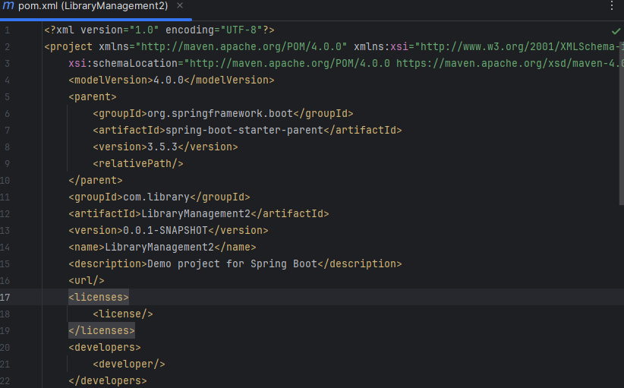

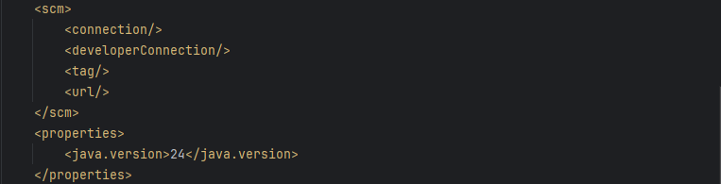

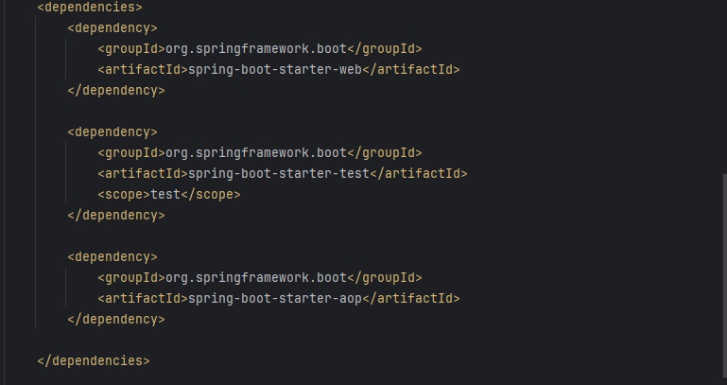

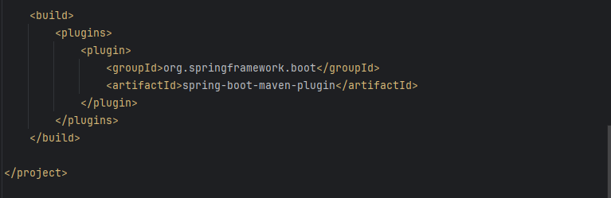

Output:

